**Q6-Ansible Document**

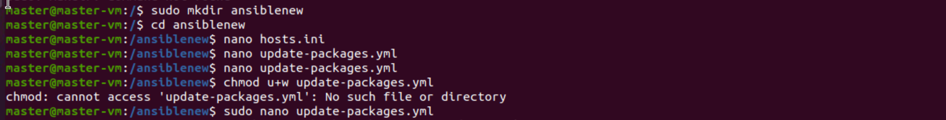

**Update package.yml**

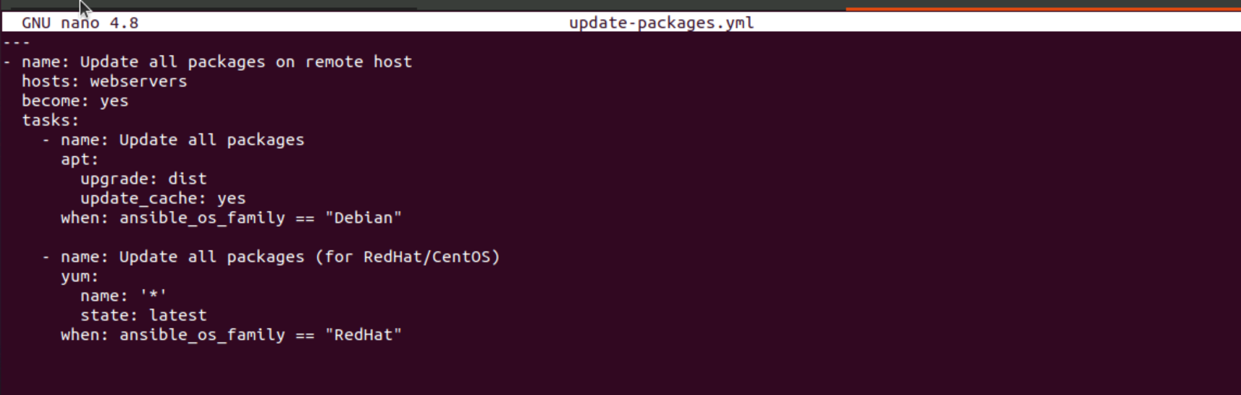

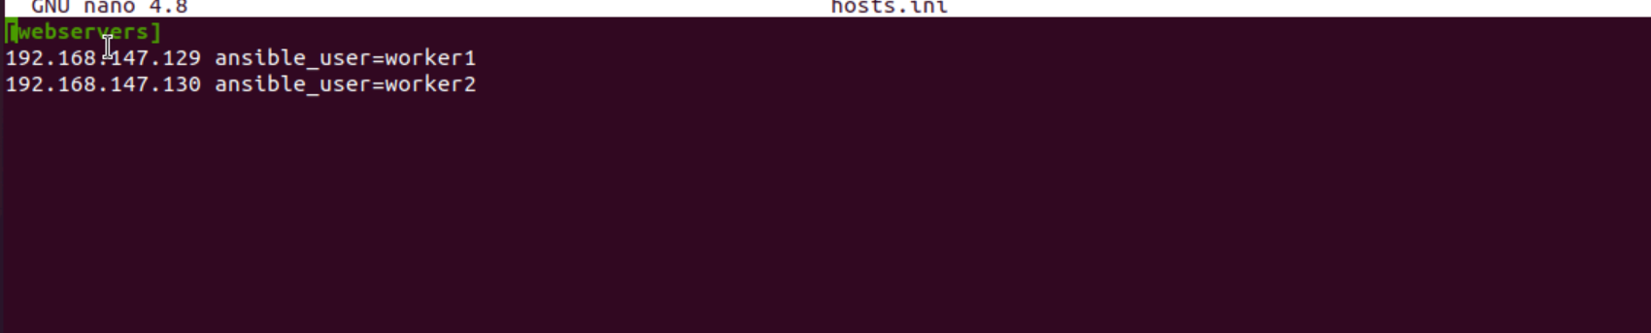

**Running the playbook**

